DSCI 5350 Assignment-3 Satyasriharsha Buddha

Databricks Published Link: https://databricks-prod-cloudfront.cloud.databricks.com/public/4027ec902e239c93eaaa8714f173bcfc/4179776347872718/3707216431996142/222406585371466/latest.html

1. Read the provided file into Spark successfully

Created a cluster-BigQuery and Scala Notebook DSCI5350-Assignment3-on-BigQuery

The file was uploaded

Path- dbfs:/FileStore/shared_uploads/sriharshabuddha@my.unt.edu/Steel_industry-1.csv

Importing Required Libraries and Loading the file into a dataframe

Checking the dataframe

2)Write Scala code to display Interquartile Range of the ‘Usage_kWh’ without using libraries.

Creating usageKWH from the dataframe and checking the values

Sorting the values in an array

Finding Median of the array and q1

Finding q3 and the difference and printing

3.Take the mean of ‘Usage_kWh’ round to next integer and break it into 3 whole numbers such that they sum up to the original number and count number of ways to do so and display it.

Finding the mean of ‘Usage_kWh’ and rounding off to the next integer

Finding number of ways to break the rounded mean into three whole numbers and displaying the answer

Write a Spark SQL query to display the details of highest ‘Usage_kwh’ in each

load type (top 3)

Forming a temporary view and verifying the data

Forming a subquery with load_type and usage_kwh partitioned by load type and usage_kwh in descending order and limiting to top 3 highest values and displaying the result

Apply any machine learning algorithm on data using Spark ML-lib and give description.

Perform linear regression and predict 'Usage_kWh' based on 'Leading_Current_Power_Factor' using Spark MLlib.

Importing the libraries and getting the data

Splitting the data into test and train dataset

Running a linear regression

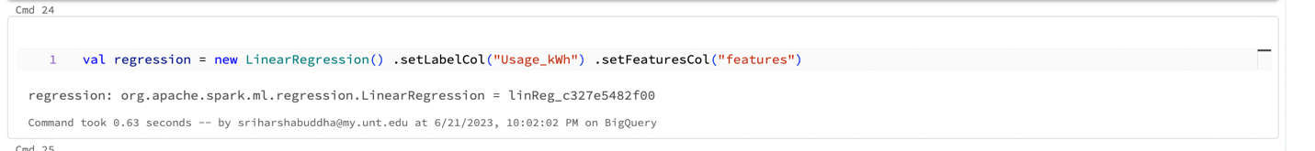

Fitting model on the training data

Showing predictions

Evaluating the model and finding out the RMSE value

Finding the R square value

Based on the given RMSE and R-squared values, we can infer that the current model's performance in predicting 'Usage_kWh' is not very accurate or strong. It may require further improvements, such as incorporating additional relevant features, trying different regression algorithms, or optimizing model parameters, to enhance its predictive power.